Case Study: Constructing a Tidal Power Plant in Saint Martin
You have recently appointed as a project manager to make a feasibility study to test a tidal type electric power generation in Saint-Martin Island. You have prepared list of activities and estimated duration time, which shows as follows
Activity code | Duration (week) | Predecessor Activity (code)
A | 2 | -
B | 3 | -
C | 5 | A
D | 5 | A
E | 6 | B
F | 1 | B
G | 4 | B
H | 5 | C
I | 3 | C,D
J | 2 | E,F
K | 4 | H,I,J
L | 2 | J,G
M | 5 | K,L
- Calculate how many minimum weeks it will require to complete the project
- What will be the slack time of each activities
- Due to resource constraint, your manager notified you that activities D, F and G can will only have 50% of resources (i.e. duration time will be doubled). Will it make the project any delay?
- By completing the project on due time (21 weeks), the company will receive an award from project sponsors´ of 5,00,000 BDT. If you feel that project will be delayed due to 50% pace of activities D, F and G you have alternate option to hire additional workers from a third party. By hiring additional resources for activities D, F and G to complete in due time it will cost 50,000 BDT each week for each activities. What will be the minimum additional cost you could allocate to hire resources from third party?
- Project Crushing:
Consider a new scenario, your stakeholders pushed you to finish the project within 19 weeks, which will gain the company a reward of 7,00,000 BDT extra from government. In order to reduce the duration time for one week for each activity extra cost information is provided below. How much minimum extra investment you need to make to complete the project within 19 weeks. Remember, you can only reduce each activity for maximum one week. You cannot reduce any activity by two weeks.
Activity | Cost (BDT) | Activity | Cost (BDT)
A | 30,000 | H | 70,000
B | 20,000 | I | 50,000
C | 50,000 | J | 30,000
D | 70,000 | K | 40,000
E | 60,000 | L | 50,000
F | 30,000 | M | 60,000
G | 60,000
Solution

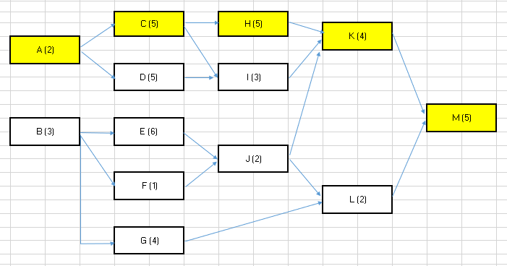

Available paths:
Paths Duration (weeks)
A-C-H-K-M 21 (Maximum), Critical path
A-C-I-K-M 19
A-D-I-K-M 19
B-E-J-L-M 18
B-F-J-L-M 13
B-E-J-K-M 20
B-F-J-K-M 20
B-G-L-M 14

Here, duration for A-C-H-K-M is maximum, which is the critical path. So, the project will require minimum 21 weeks to complete.

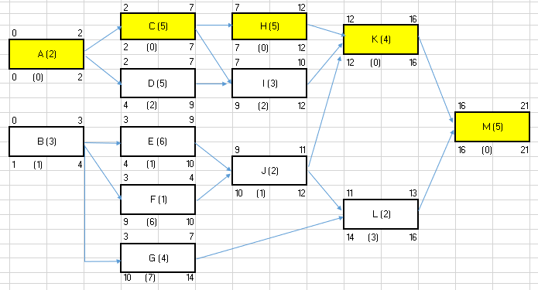
Slack time

Alternate way
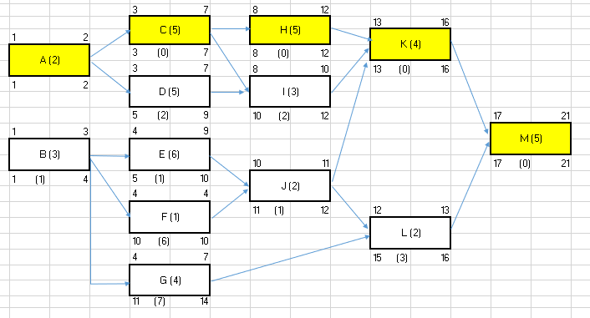
Notes: Standard symbol
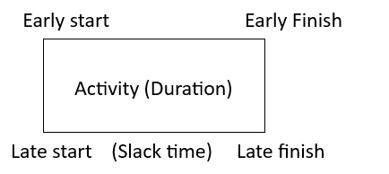Slack time = Early start- Late Start

- Here, the duration time for D, F and G would be 10, 2 and 8 weeks respectively. So, from previous scenario, the duration time for activities D, F and G would be increased by 5, 1 and 4 weeks respectively. The slack time for D, F and G is 2, 6 and 7 weeks. So, the increased duration for F (1)and G (4) is less than their slack time. So it will not change the completion time of the project.
However, for activity D, slack time is 2 weeks and duration time will be increased by 5 weeks, which is greater than slack time. So, project will be delayed by (5-2)= 3 weeks due to increased duration of activity D.

Sample proof (D, F and G would be increased by 5, 1 and 4)

A-C-H-K-M 21
A-C-I-K-M 19
A-D-I-K-M 19 +5 = 24
B-E-J-L-M 18
B-F-J-L-M 13 + 1 = 14
B-E-J-K-M 20
B-F-J-K-M 20 +1 = 21
B-G-L-M 14 +4 = 18

- As the activity, D is the main constraint that will delay the completion time of the project, we need to hire additional resource for activity D only. As, activity D has already 2 weeks of slack time, we need to hire resource for 3 weeks only. In such case, amount need to be paid by (3 x 50,000) = 1,50,000 BDT to hire additional resource. By investing 1,50,000 BDT company can still gain (5,00,000 – 1,50,000) = 3,50,000 BDT of extra profit by completing the project within 21 weeks.

- Project crushing

In this case, we need to look at the critical path, as by reducing the duration time on activities within critical path, we can reduce the overall completion time of the project. Here, critical path is A-C-H-K-M total 21 weeks.

Next, we need to look at the minimum cost require to reduce the duration time of each activity by 1 week. Among, activities A, C, H, K, M cost to reduce 1 week is less for activity A (30,000 BDT) compared to other activities. So, we will reduce the activity A to 1 week 1st by additional investment of 30,000 BDT.

Now, we have to recalculate the critical path, reducing the duration time of activity A by 1 week. New critical paths will be as follows

Paths Duration (weeks)
A-C-H-K-M 20 (A reduced by 1 week)
A-C-I-K-M 18
A-D-I-K-M 18
B-E-J-L-M 18
B-F-J-L-M 13
B-E-J-K-M 20
B-F-J-K-M 20
B-G-L-M 14

At this stage, we have 3 critical paths. On this 3 critical paths, activity K and M is common. So, if we reduce the duration time for either K or M by 1 week, it will reduce the whole project´s deration time to 19 weeks. Among K and M, extra cost require to reduce the time is minimum for activity K (40,000 BDT), compared to M (60,000 BDT). So, we will choose activity K to reduce its duration time.
So, by reducing activity A and K, 1 week each we can reduce the project´s completion time to 19 weeks having minimum 70,000 BDT of extra investment.
Notes:
- Critical path is not constant. It may change throughout the project.
- On critical path, slack time of those activities is zero (0)
- Project crushing is important for different types of business. For example, by reducing deration time of launching new product, company can gain extra profit from selling more product within those time line. Another example could be completing the new road, or maintenance of roads, we can save the working hour of people.

